Research for Graph Theory Project 2020

Problem Statement

You must write a program in the Python programming language [2] that can build a non-deterministic finite automaton (NFA) from a regular expression and can use the NFA to check if the regular expression matches any given string of text. You must write the program from scratch and cannot use the re package from the Python standard library nor any other external library. A regular expression is a string containing a series of characters, some of which may have a special meaning. For example, the three characters ., |, and \* have the special meanings concatenate, or, and Kleene star respectively. For example, the regular expression 0.1 means a 0 followed by a 1, 0|1 means a 0 or a 1, and 1\* means any number of 1’s. These special characters must be used in your submission. Other special characters you might consider allowing as input are brackets () which can be used for grouping, + which means at least one of, and ? which means zero or one of. You might also decide to remove the concatenation character, so that 1.0 becomes 10, with the concatenation implicit. You may initially restrict the non-special characters your program works with to 0 and 1. However, you should at least attempt to expand these to all the digits, and the characters a to z, and A to Z.

What is Thompson’s Construction?

Thompson’s construction is a way of converting a regular expression into a non-deterministic finite automation(NFA). It was designed by Ken Thompson. It is also called the McNaughton-Yamada-Thompson Algorithm.

What is the Shunting Yard Algorithm?

It is a method for parsing mathematical expressions that are specified in infix notation. It was created by Edsger Dijkstra.

Results of running the myScript.py

Pre-defined test

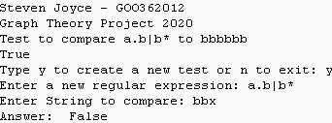

User Test True

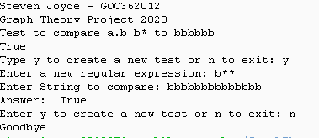

User Test False

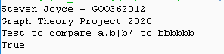

Wrong User Input

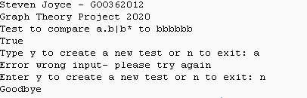

Exit the Program

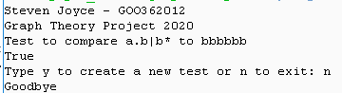

Steps to convert a regular expression into an NFA

1. Generate a regular expression
2. Develop an algorithm that will be used in conversion
3. Parse the regular expression from infix to postfix
4. Create small NFA’s to be used for parts of the regular expression
5. Utilize the NFA’s created to create a complete NFA
6. Now use a matching algorithm with the NFA
7. Generate the result

References

Webpages

<https://en.wikipedia.org/wiki/Thompson%27s_construction>

<https://www.tutorialspoint.com/automata_theory/constructing_fa_from_re.htm>

<https://www.researchgate.net/figure/Thompsons-NFA-construction-The-regular-expression-for-a-character-a-S-corresponds-to_fig1_1959575>

Videos

<https://www.youtube.com/watch?v=6YH9wsLM-8o> – Barry Brown

<https://www.youtube.com/watch?v=RYNN-tb9WxI> – Barry Brown

<https://www.youtube.com/watch?v=84oNUttWlN4&feature=youtu.be&t=105> – Neso Academy